Questions and/or Exercises to work out and turn in:
Grading Guidelines:
A right answer will get full credit when:
- It is right (worth 25%)
- It is right AND neatly presented making it easy and pleasant to read. (worth an extra 15%)
- There is an obvious and clear link between 1) the information provided in the exercise and in class and 2) the final answer. A clear link is built by properly writing, justifying, and documenting an answer (worth an extra 60%).
- Calculation mistakes will be minimally penalized (2 to 5% of full credit) while errors on units will be more heavily penalized.

You are welcome/encouraged to discuss exercises with other students or the instructor. But, ultimately, personal writing is expected.

- USE THIS FILE AS THE STARTING DOCUMENT YOU WILL TURN IN. DO NOT DELETE ANYTHING FROM THIS FILE: JUST INSERT EACH ANSWER RIGHT AFTER THE RELATED QUESTION.
- IF USING HAND WRITING (STRONGLY DISCOURAGED), USE THIS FILE BY CREATING SUFFICIENT SPACE AND WRITE IN YOUR ANSWERS.
- FAILING TO FOLLOW TURN IN DIRECTIONS /GUIDELINES WILL COST A 30% PENALTY.

Objectives of this assignment:
- to use and manipulate the concepts presented in this module
- to use and manipulate the definitions of O(g(n)), Ω(g(n)), and Θ(g(n))
- to get familiar with the “order” of usual functions: polynomials, square root, logarithms, exponentiatl...

What you need to do:

Answer the questions and/or solve the exercises described below.

The objective of this assignment is to study a naïve sorting algorithm: NaïveSort. You must prove the correctness of NaïveSort and evaluate its performance.

NaïveSort works by repeatedly swapping adjacent elements that are out of order. Below is its pseudocode of the simplified NaïveSort algorithm.

NaïveSort(A)
1 for j = A.length downto 2
2 for i = j-1 downto 1
3 if A[j]< A[i]
4 exchange A[j] with A[i]

Part I (45 points) Correctness
a. Let A denote the output of NaïveSort (A). To prove that NaïveSort is correct, we need to prove that it terminates and that
A[1] ≤ A[2] … A[n] , (2.3)
where n = A.length. In order to show that NaïveSort actually sorts, what else do we need to prove?
Answer the next two questions b. and c. to prove inequality (2.3). You also have to prove the output array contains the same elements as the input array

b. (20 points) State precisely a loop invariant for the for loop in lines 2–4, and prove that this loop invariant holds. The loop invariant must be useful, i.e., it must help prove Property 2.3. Your proof should use the structure of the loop invariant proof presented in this chapter:
(5 points) Loop invariant is: answer here ..... At the start of each iteration of the inner loop (for a fixed j), the element A[j] contains the smallest element among A[i+1], A[i+2], …, A[j].
Equivalently, after processing indices from j−1 down to i+1, the minimum of the subarray A[i+1..j] is stored in position A[j].
This invariant is useful because it shows that, after the inner loop finishes, A[j] contains the minimum element of A[1..j].

(3 points) Initialization: answer here ..... At the beginning of the inner loop, we have i = j−1. The subarray A[i+1..j] then consists only of A[j]. Trivially, A[j] is the minimum of this one-element set. Therefore, the loop invariant holds before the first iteration.

(8 points) Maintenance: answer here ..... Assume the invariant holds at the start of an iteration for some i. That means A[j] is the minimum of A[i+1..j]. We compare A[j] with A[i].
- If A[j] < A[i], we swap A[j] and A[i]. After the swap, the smaller of the two values is placed in A[j].
- If A[j] ≥ A[i], no swap occurs, and A[j] is still the minimum among A[i..j].
In both cases, after this step, A[j] contains the minimum of A[i..j]. When the loop index decreases to i−1, the invariant continues to hold for the next iteration. Thus, the invariant is maintained.

(4 points) Termination: answer here ..... When the inner loop terminates, we have processed all indices from j−1 down to 1. By the loop invariant, A[j] now contains the minimum element of A[1..j]. Therefore, after the inner loop finishes, the smallest element among A[1..j] is correctly placed at position j.

c. Using the termination condition of the loop invariant proved in part (b), state a loop invariant for the for loop in lines 1–4 that will help you to prove inequality (2.3). Your proof should use the structure of the loop invariant proof presented in this chapter:
(6 points) Loop invariant is: answer here ..... At the start of each iteration of the outer loop with index j, the subarray A[j+1..n] contains the (n − j) largest elements of the array in sorted (nondecreasing) order, and every element in A[1..j] is less than or equal to every element in A[j+1..n].
This invariant helps prove that the array becomes fully sorted when the loop finishes.

(4 points) Initialization: answer here ..... Before the first iteration, j = n. The subarray A[j+1..n] = A[n+1..n] is empty, which is trivially sorted and satisfies the invariant. Therefore, the loop invariant holds before the first iteration

(10 points) Maintenance: answer here ..... Assume the invariant holds at the start of an iteration for some j. From part (b), after the inner loop finishes, A[j] contains the minimum element of A[1..j]. Thus, A[j] is correctly placed relative to the elements in A[j+1..n].
Since A[j+1..n] was already sorted and contains the largest elements, placing the correct element at A[j] preserves the property that A[j..n] is sorted and contains the largest (n − j + 1) elements in correct order. Therefore, when j decreases to j−1, the invariant continues to hold.

(5 points) Termination: answer here ..... When the outer loop terminates, we have j = 1. By the loop invariant, the subarray A[2..n] is sorted and contains the largest elements, and A[1] is less than or equal to all elements in A[2..n]. Therefore, the entire array A[1..n] is sorted, i.e.,
A[1] ≤ A[2] ≤ … ≤ A[n].
This proves inequality (2.3). Since the algorithm only swaps elements, the output is a permutation of the input. Hence, NaïveSort is correct.

Part II (45 points) Running Time of NaïveSort
- (2 points) What is the input size? answer here ..... The input size is n = A.length, the number of elements in the array.
- (3 points) What is the operation that you will count? answer here ..... the comparison operation in line 3. If A[j] < A[i]
- (40 points) Let T(n) be the running time of NaïveSort. Derive the asymptotic bound for T(n).
answer here ..... We expect that you use a table like the previous homework assignment to derive the time complexity and follow the same steps. If you have any doubt, ask.

Let n = A.length be the input size. We count the comparison in line 3: if A[j] < A[i]
Line | Statement | Cost per execution | # of executions | Total cost
1 | for j = n downto 2 | c1 | n-1 | c1 (n−1)
2 | for i = j-1 downto 1 | c2 | $$\sum_{j=2}^{n}{\left(j-1\right)}$$ | c2 ∑j=2n (j−1)
3 | if A[j] < A[i] | c3 | $$\sum_{j=2}^{n}{\left(j-1\right)}$$ | c3 ∑j=2n (j−1)
4 | exchange A[j] with A[i] | c4 | ≤  $$\sum_{j=2}^{n}{\left(j-1\right)}$$ | ≤c4 ∑j=2n (j−1)

Now compute the dominant term:

$$\sum_{j=2}^{n}{\left(j-1\right)}=1+2+3+…\left(n-1\right)=\frac{n\left(n-1\right)}{2}$$

Therefore, the total running time is:

T(n)=c1 (n−1)+(c2 +c3 +c4 ) n(n−1) /2

Ignoring constants and lower-order terms, we get:

T(n)=Θ(n^2)

Conclusion: The running time of NaïveSort grows on the order of n^2.

Part III (10 points) Space Complexity
- (2 points) Is NaïveSort an in place algorithm? answer here ..... Yes, NaïveSort is an in-place algorithm, because it only uses a constant amount of extra space and rearranges elements within the input array.
- (8 points) What is the space complexity of NaïveSort if we do not count the space used by the input.

answer here ..... If we do not count the space used by the input array, the algorithm only uses a constant number of extra variables (for indices and swapping). Therefore, the space complexity is: $Θ(1)$

Appendix: Grading: What is an OBVIOUS and CLEAR LINK?
Here is an example to explain what an obvious and clear link is and how we grade your work.
Consider the following problem:
"(100 points) John travels from Auburn to Atlanta in his car at a speed of 60 mph. Leaving at 8am, at what time will John reach Atlanta".
Here are the answers of three students and their scores:
- Student 1 answers: "9:48am". Student 1 will get 25 points.
- Student 2 answers : "John will reach Atlanta at 9:48am". Student 2 will get 25+15 = 40 points
- Student 3 answers: "The time t to travel a distance d at speed v is equal to d/v = d/60mph. The problem does not provide the distance d from Auburn to Atlanta. Based on GoogleMaps, the distance from Auburn to Atlanta is approximately 108 miles (document is attached).
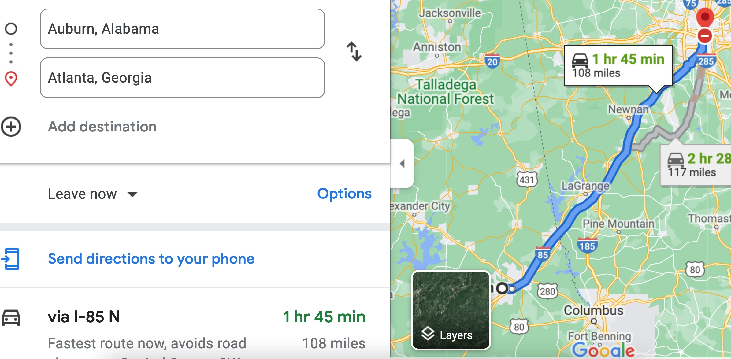

Therefore, the time t = 108 miles/60mph * 60 minutes/hour= 108 minutes. Since John left at 8am, he will then reach Atlanta at 8am + 108 minutes = 8 am + 60 minutes + 48 minutes = 9:48".

Student 3 will get 25 + 15 + 60 = 100 points
Do you see the direct link going from the data provided in the question to the final answer, using general knowledge/formula and documents?.... Can you now solve the following problem and get 100 points?
"(100 points) Alice travels from Auburn to Atlanta in her car at a speed of 60 mph. Leaving at 8am, at what time will Alice reach Atlanta assuming that she had a flat tire that delayed her 30 minutes".

